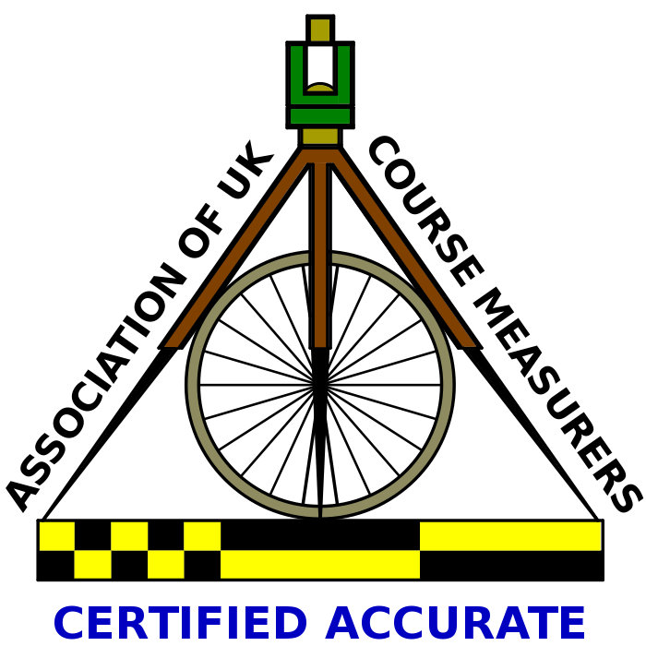  UK Athletics
Licence No 2013-105805

Upton Bishop Big Dipper
5.64 Miles
Sunday 29th September 2013

Start 11.00am from Upton Bishop Millennium Hall
[Plus children’s fun runs start 10.30am]

Medal and free tea and cake for all finishers

SURNAME: FIRST NAME:

ADDRESS:

POSTCODE:

CONTACT NUMBER:

E-Mail:

DATE OF BIRTH: AGE ON RACE DAY:
[Minimum Age 15years]

GENDER: MALE / FEMALE

UK Athletics affiliated CLUB:

FEE PAID: UK Athletics MEMBER: £6.00 NON MEMBER: £8.00
Plus £2 for entry on the day

Cheques made payable to Upton Bishop Sports and Social Club

Results will be posted on www.uptonbishop.org as soon as possible after the event
If you require printed results please enclose a large stamped addressed envelope.

DECLARATION:
I confirm that I am fit to compete in this event and absolve the organisers from any responsibility and run entirely at my own risk. I will compete on foot and understand that no accompanying dogs or following cycles will be allowed.

SIGNED: DATE:

Return to: Mr.N.Misselbrook, Ryelands, Upton Bishop, Ross-on-Wye, Herefordshire, HR9 7TU.
[Race Numbers issued on the day.]

