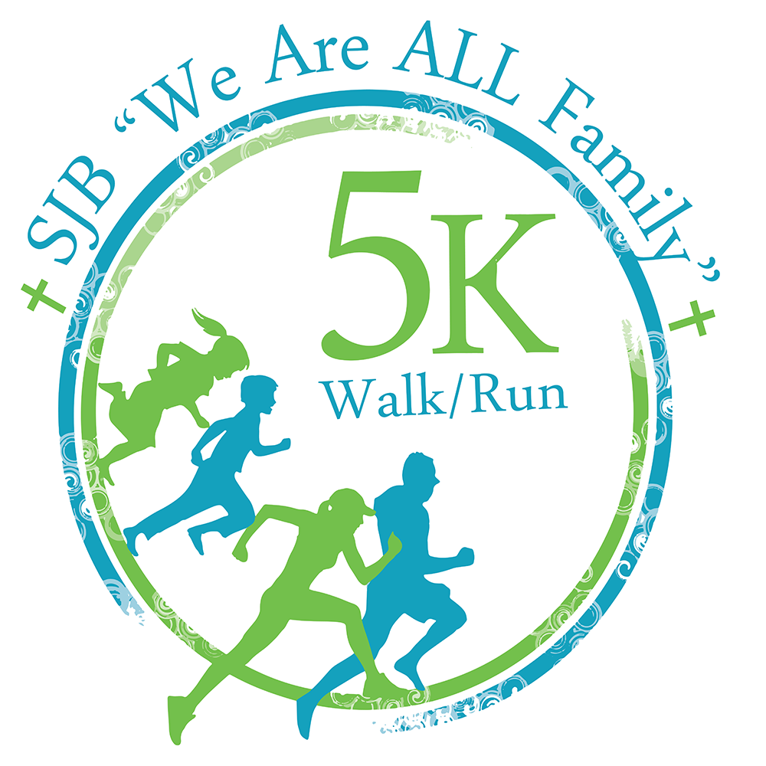
St. John the Baptist School
1st Annual "We Are ALL Family" 5k Walk/ Run
DCR’s Chicopee Memorial State Park, Burnett Road, Chicopee Falls
Saturday, May 18, 2013
Website and online registration: www.sjbludlow.org/5krace
email: 5krace@sjbludlow.org


To benefit: St. John the Baptist Family School Association
5k Run / Walk: 10am Kids in Motion Activities: 9:30 am Race Day Registration: 8:30am

Early Registration Walk/ Run: $25** Student Walk/ Run: (grades PK-8) $10**
SJBS Kids In Motion Activities: (ages 5-12) $10**, (ages 0-4 free) signed entry form required, an adult must remain with child. Children may collect cash sponsorship money (to be handed in day of event)
Kids in Motion Award: $100 Cash Prize awarded to the child who collects the most cash sponsors.
Awards are given to the top 2 male and top 2 female runners in each age group.
Free T-shirts for first 200 Pre-registered runners/ walkers
* lunch ticket included with registration fee, cook out- lunch items available. **$5 late fee added to registrations received after April 25


BIB #
First Name: 
Last Name:    OFFICIAL USE

M F
Age on May 18:    Gender   OFFICIAL USE
Address: 
City:  State     Zip 
Email: 
Event Check One:  5k Run*  5K Run Student* *  5k Walk*  5K Walk Student**  SJBS Kids in Motion*
*Lunch ticket included with registration fee.

Amount Enclosed (5k Walk/ Run $25 before April 25, $30 post and race day)____, (Students $10 before April 25, $15 post and race day)____, (Kids in Motion $10)____, Kids in Motion cash sponsorship collected: turn in day of event
Kids 4 & under-(free) _____ ** Kids Rate 5K is for PK- 8th grade_____

Mail completed form and make checks payable to: St. John the Baptist Family School Association
Attn: 5K
217 Hubbard Street, Ludlow, MA. 01056

AS AM AL AXL YS YM YL
T-shirt Size: (5k Walk/ Run Only)                      T-shirts can only be guaranteed for first 200 entrants

Emergency Contact _____________________________ Emergency Phone _____________________

In consideration of this application being accepted, I hereby for myself, heirs, executors, and administration waive and release any and all rights and claims for damages I have against race officials, race volunteers, St. John the Baptist School, DCR’s Chicopee Memorial State Park, Town of Chicopee and all other agencies, representatives, successors, and assigns for any and all injuries suffered at said event or while traveling to or returning from. I attest I am physically fit to compete in this event.
Signature of Participant (Or Guardian if under 18): ___________________________________ Date: ______________

