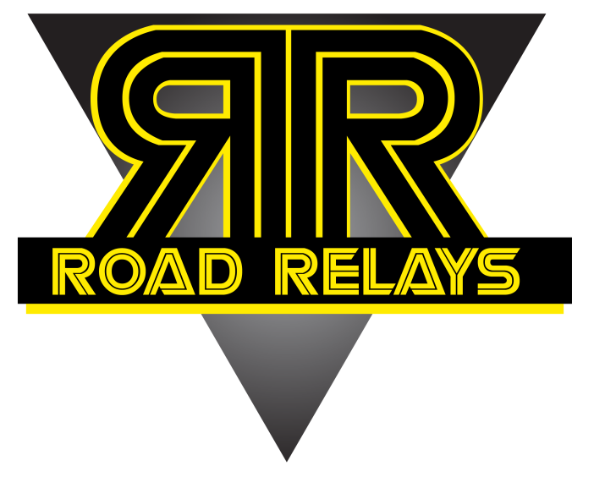

THE EVENT
Each team consists of two members who each run two 2.5k legs.
Each leg is two laps around the road in Buccleuch Park, for a total of 8 laps or 10k. Batons are provided!

REGISTRATION
$40/team by February 20
$50/team on race day

On-Line @ RaceForum.com

DIVISIONS
Open
High school
Youth (14 & under)
College student
Greek (Frat/sorority)
Rutgers alumni
Costume
Parent/child
Sibling
Masters 40-49
Masters 50-59
Masters 60-69
Masters 70+
AWARDS
Medals to top three teams in male, female, co-ed categories of ALL divisions

February 24, 2013
11:00am
Buccleuch Park, New Brunswick
www.roadrelays.org
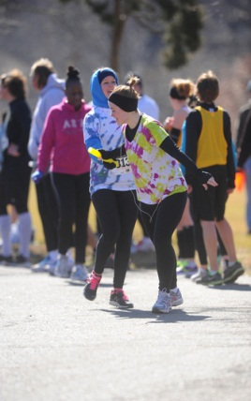
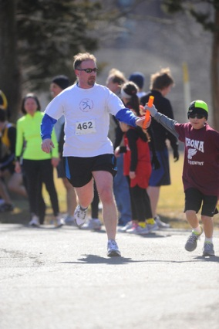

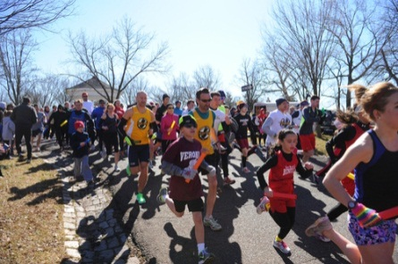

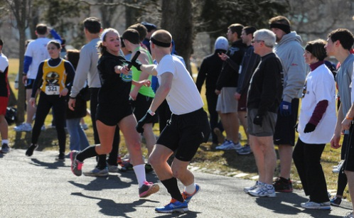
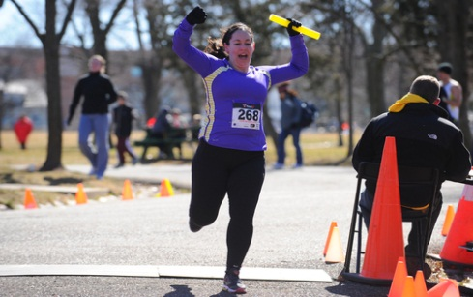

Proceeds from this race benefit “Essays 4 Equipment”, a community outreach program done by the Garden State Track Club, a 501(c)3 nonprofit organization serving underprivileged youth runners in New Jersey.

Mail to: Meet Director, 10 Dennis Street #237 New Brunswick, NJ 08901 Checks payable to: “Garden State Track Club”

__________________________________________
Name
__________________________________________
Street City State ZIP
__________________________________________
Gender (M/F) Age on Race Day DOB (mm/dd/yy)
__________________________________________
E-mail

Division________________________________________________________

__________________________________________
Name (include even if teammate is registering on separate form)
__________________________________________
Street City State ZIP
__________________________________________
Gender (M/F) Age on Race Day DOB (mm/dd/yy)
__________________________________________
E-mail

Circle: Male, Female, Coed

Waiver: I, intending to be legally bound, hereby for myself, my heirs, executors, and administrators, waive and release any and all rights and claims I may have against Garden State Track Club, the county of Middlesex, City of New Brunswick, all sponsors, and other persons or organizations connected with the above named event, and their respective agents, employees, officers, volunteers, representatives, successors, and assignees for any and all injuries that may be suffered by me in connection with this event. Further, I hereby certify that I am physically able to participate in this event and hereby grant the right to publish my name in the news media and use my likeness in any photographic record for the Garden State Track Club 10K Road Relay. Rain or shine, no refunds
__________________________________________ ______________________________________
Signature (Parent/Guardian if Under 18) Date Signature (Parent/Guardian if Under 18) Date

